09.06
Pooling & Consignment
Process Design & AMOS Configuration Document
Purpose
This Process Design document is provided to Key-Users to record their key decisions regarding the AMOS Process design and the required AMOS configuration.
It is updated throughout the Project Definition Phase and used as the baseline for the Final Acceptance prior to Go-Live
Revision
Author, Name | Date | Notes
Daniele Musella | 01.06.2024 | First version

Table of Contents

1. Process Overview & Objectives 3
2. Regulatory References 3
3. Definitions & Glossary 3
4. Process Tasks 4
5. Process Dependencies 7
6. Process Flow 8
7. Process Design Questions 12
8. Data Source Mapping 13
9. Other Software Used 13
10. AMOS Configuration 13
a. Process specific configuration programmes 13
b. Basic Data 13
c. Parameters 13
d. Workflows 14
e. Scheduled Tasks 15
f. API’s & Interfaces 15
11. UAT Guidance 15
12. Annex – Additional Info 16

Process Overview & Objectives
Process General Description
This Business Process explains, depending to the use case in subject, how to procure material to your organization under Pool or Consignment Contracts from external vendors (you are the customer) and how to provide material to your customers under Pool or Consignment Contracts (you are the provider)

Main Process Objective (Outputs & Outcomes)
The main objective of Pooling & Consignment is to:
- Fulfil the material demand of your organization through:
  - Pool Contracts (you are the customer): both in for “exchange in advance” use case and for “exchange” use case (Base Kit replenishment)
  - Consignment Contracts (you are the Consignee): consignment stock replenishment
- Provide material to your customers, through:
  - Pool Contracts (you are the provider): both in for “Customer Pool Request (Exchange in Advance)” use case and for “Customer Pool Request Exchange (Exchange)” use case
  - Consignment Contracts (you are the Consignor): customer’s consignment stock replenishment

Regulatory References
There is no worldwide authority regulation applicable to this process.

Definitions & Glossary
Key-Words | Explanation
Pool Contract | To manage your contracts with your pool providers, as a pool participant (you are requesting parts from a pool provider) you need to define one or several pool contracts in the Contract Management (APN 780) prior being able to issue pool requests. Usually, the material included in a Pool Contracts are Rotables
Pool Project | Another precondition is the existence of one or several pool projects which are needed to define a pool contract.  The pool project gives you a good financial overview over the cost associated with the pool according to the pool contract (cost control)
Partner Company | In a Pool Contract (you are the pool customer) with this term the pool provider is named in AMOS. Its address code needs the property "Pool Participant" in Address Administration.
Base Kits | Base Kits is material owned, usually, by the pool provider, but located on pool customer's stations which is purchased, managed and maintained by the provider of the pool. If material is consumed an order has to raised. The pool provider will replenish the stock IAW the pool contract. Some contracts provide the possibility to set up Base Kit with material owned by pool customer but repaired by pool provider and replenished as well IAW pool contract.
Consignment Contract | To manage your contracts with your vendor, as a pool “Consignee” (you are requesting parts from a “Consignor”) you need to define one or several Consignment contracts in the Contract Management (APN 780) prior being able to Consignment Orders. Usually, the material included in a Pool Contracts are Consumables, but AMOS can also accommodate creation of Consignment contracts for CR and Rotables

Process Tasks
The main business processes and related AMOS APNs are the following:
Procuring material for your organization under Pool Contracts (you are the Pool Customers)
It is possible to cover the following use cases:
- Exchange in Advance. You request serviceable material to your pool provider before sending the US counterpart to your pool provider. This is accomplished in AMOS via PR-order (Pool Request Order)
- Exchange. You request serviceable material to your pool provider when you already have your US counterpart to return to your pool provider. This process is usually meant to replenish the Base Kit at your facilities and in AMOS it is accomplished via PX-order (Pool Request Exchange Order)
- Initialization of Base Kit. Different strategies depending on the context: usually, the most common are data migration or PR/PU-order (with specific project) or receiving of a P-order with the customer code=pool provider
- Base Kit return at the end of the Contract. Depending how the Base Kit was initialized, it can be accomplished in AMOS either via D-order (especially if the installation was done via data migration or P-order) or via PU-order in case (the one correspondent PR-order of initialization, if initialization was done via PR-order)

Preconditions to use Pool Contracts in AMOS is to define one or several pool contracts in the Contract Management (APN 780) prior being able to issue pool requests. Usually, the material included in a Pool Contracts are Rotables. See process 09.02 Supplier Management.
In case of Pool Contract as customer, the contract type in APN 780 is “POOL_PAR”, and you must define the “effectivity” of the contracts in terms of Aircraft covered and Part Numbers covered.

In addition, it is possible to define the contractual Base Kit level (either at global level or per station) so as, during the operation of the contract, it is possible to compare the current stock level with Contractual level (APN 2028, Pool Base Kit Report).

Invoicing process
- For structured Pool contracts that involve PBH (Power By the Hour) fees based on aircraft’s age (e.g: xx $/fhs for aircraft with age between 0-1 year, yy $/fhs for aircraft with age between 1-2 years and so on) it is recommended to use Service orders linked to specific project, and ask Pool provider to invoice with reference to those orders
- It is recommended to open additional lines in the same Service orders for O&A (Over & Above) costs like scrap, service bulletins, mishandling, misuse and so on.
KPIs definition and monitoring
- Pool Contracts often involve very precise contractual times to be respected both for the pool provider (time that elapses between the receiving of customer pool order and delivery of material) and for the pool customer (time that elapses between the receiving of serviceable part and restitution of the unserviceable part to pool provider).
- Failure to respect contractual terms can involve heavy operational impacts as well as possibility to incur penalties, both for the pool provider and for the pool customer.
- For those reasons, it is highly recommended to set-up and monitor in AMOS KPIs for delivery and restitution times (PR, PU, PX) according to contractual provisions.
  - Set up is be done in Logistic Configuration (APN 1014), by defining the start/end points for the single TATs for single order types, as well as all intermediates milestones that enable you to measure the single sub-TATs providing in this way the possibility to understand what is the part of the process needing improvements.
  - Monitoring is done in Order Tracking (APN 1328), where in the tab “TAT report” are displayed the TATs for all orders selected in the tab “order list”
- Another operational KPI that is recommended to be monitored is the "filling level" of the Base kit. This can be done directly in “Pool Base kit report” (APN 2028) where you can compare for each part number defined as Base Kit, the current level versus the contractual one and to take corrective actions in case the filling level is lower than contractual one, and/or criticalities arise on specific parts. A poor base kit fulfilment level can be due both to low service level on pool provider side (in replenishing the Base kit upon PX orders) and to issues on your internal logistics (because the parts in Base kit are used but the unserviceable counterparts are not promptly available to be booked and returned back on the PX orders): the pool manager, therefore, starting from the outcome provided by “Pool Base kit Report”, has to investigate and look for the root causes behind any issues about the Base kit level
Procuring material for your organization under Consignment Contracts (you are the Consignee)
A consignment contracts usually provide building and replenishing a stock of material to Consignee’s facilities, based on reorder level for each part number, so as that material can be used during the operation without incurring (or mitigating the risk) in situations of zero stock for those materials covered by the Consignment Contract.
Usually, the material included in a Pool Contracts are Consumables, but AMOS can also accommodate creation of Consignment contracts for CR and Rotables.
- The main consignment order is the SI-order, used to replenish your consignment stock. When the material is received in your consignment stock, in AMOS it is owned by the Consignor, as it remains in such a condition as long as it will be consumed
- When the material in the consignment stock is consumed (booking of relevant pickslip), AMOS will automatically create a SP-order (Consignment Stock Purchase order) and will change the ownership of the part (form Consignor to Consignee), so as the consumption will be registered as consumption of “owned” material (and therefore produce costs also in the AMOS Finance module)
- The return of serviceable to the consignment stock is performed as any other return of serviceable material, namely through pickslip cancellation: in this case, when the pickslip is cancelled, AMOS will automatically create a SU-order (Return Stock Consignment order) and perform an owner change of the material (from Consignee to Consignor)
Usually, the material included in a Pool Contracts are Consumables, but AMOS can also accommodate creation of Consignment contracts for CR and Rotables.

Even though it is NOT a precondition, it is strongly recommended to use Consignment Contracts in AMOS to define one or several Consignment contracts in the Contract Management (APN 780) prior issuing consignment orders.

In case of Consignment Contract as customer (Consignee), therefore, in APN 780 you have to create a Consignment Contract (contract type= “CONS”), and you should define in it:
- the “Supply Scope” of the contracts in terms of material covered (at material class and/or material type and/or part special, or even at part number level). This scope can be defined at global level or even broken down at station level.
- The “Price Book” of the single parts covered by the Consignment Contract that will be used during the SI-order process and that will be used as a reference also for in the automatically created SP-order (default behavior that can e changed via parameter)
- The “aggregation strategy” of the SP-order for the material consumed from the Consignment Stock (all parts consumed within the defined period will be aggregated in a single SP-order)

In addition,
- in order to allow AMOS check the Supply Scope during the creation of SI-order, you should set the field “Contract ID” as mandatory in APN 1444.
- If you require that all the parts in the SI-order must be linked to the price book of the contract, you should set WF in order management (WF 612 or WF 352) with abort condition in case this condition is not fulfilled.

Providing material for your customers under Pool Contracts (you are the Pool Provider)
If you are the Pool Provider, the process and setup are similar to the ones seen when you are then pool customer see above), but clearly everything now works in the opposite direction.
- To respond to a “pool request” coming from the pool customer (exchange in advance for the customer), you need to issue a “Customer Pool Request Exchange order” (exchange for you), by sending a serviceable part. In AMOS, from 24.6, the order type in to use in this case is the ZX-order. If you are using previous version of AMOS, you can still use the PX-order.
- To respond to a “Pool Request Exchange” coming from the pool customer (exchange for the customer), you need to issue a “Customer Pool Request order” (exchange in advance for you), by sending a serviceable part. In AMOS, from 24.6, the order type in to use in this case is the ZR-order. If you are using previous version of AMOS, you can still use the PR-order.

Preconditions to use Pool Contracts in AMOS is to define one or several pool contracts in the Contract Management (APN 780) prior being able to issue pool requests. Usually, the material included in a Pool Contracts are Rotables. See process 09.02 Supplier Management.
In case of Pool Contract as provider, the contract type in APN 780 is:
- From AMOS 24.6 onwards: “POOL_PRO”, and you must define the “effectivity” of the contracts in terms of Aircraft covered and Part Numbers covered.
- Up to AMOS 24.6 excluded, you can still use “POOL_PAR”, like the use case when you are the pool customer (see above).

Providing material for your customers under Consignment Contracts (you are the Consignor)
If you are the Consignor, in AMOS does not exist a specific contract type and/or specific order type. Anyhow, you can still follow the process explained in then prices flow to chapter 6.

Main APNs concerned.
- Order Management (APN 2015). It is the main APN where all the mentioned order types are created, issued and booked (for the bookable order types).
- Advanced Reorder Proposal (APN 899). From this APN it is possible to trigger the SI-order creation à see also process 09.01 Material Planning
- PCF (Part Consumption Forecast, APN 204). From this APN it is possible to trigger the order creation for all those part numbers whose status is “Unavailable”, both for Pool Contracts (PR-order) and Consignment contract (SI-order).
- Approval Control Board (APN 2110). From this APN it is possible to approve those orders that need an approval according to the company policy set in then Approval Control Configuration (APN 2111) à see process 04.04 Approval Control. Usually, PR/PX order are not subject to approval if being there is a PBH contract.

Form Configuration
The Form Configuration (APN 1444) allows the administrator/key-user to configure forms, modules and certain program rules according to the needs of the company. Define mandatory fields which must be filled with data by your users or hide entry fields completely, etc. for Order Management, Goods Receiving, Component Inspection & Records and Shipment.
- For Consignment Contract in order to have the “Supply Scope” checked in the SI-order, it is mandatory to set “Contract ID” filed as mandatory. In this case, in fact, if you enter a PN that does not match the supply scope and it is not linked to a Price Book of the contract, the field “Contract ID” is empty and cannot be fulfilled.

Order Approval
The Order Approval process is activated via Parameter 1440. If activated, an Order cannot be printed until it is approved within the Approval Control Program (APN 1337). The maximum ordering amount is defined in Logistics Administration (APN 1014). The maximum order amount can be defined per Order-type. The Workflow “Approval Control-ID91” should be activated to communicate the Approval requests. In urgent cases, a Buyer may “By-pass” an Order max-amount, but this Order will also flow through the approval control process.

Unknown Part Numbers
Unknown part numbers can be entered as part requests, but unknown part numbers cannot be ordered. Therefore, a process must be defined that will communicate to the responsible department to validate the created part number and if valid to create the unknown part numbers in Part Administration (APN 59). The workflow “Unknown Part Number Entered-ID197” can be activated to communicate this information.

Order Tracking
All Orders are searchable in Order Tracking (APN 1328). This report can be filtered by order state, order responsible, and order vendor. As in all table-views in AMOS, this table can be exported to Excel. The financial value of open Orders can be reviewed in the Financial Reports (APN 1355) “Value on Open Orders” report. An automatic “Order Reminder” service can be activated via the Scheduler Task “OrderReminderService”.

Order Reports
All order reports forms are stored in the Report Designer (APN 966), customizable to your own needs. Please note that Swiss-AS/AMOS does not support and maintain customized reports. After each AMOS version upgrade customized forms in the Report Designer need to be tested.

Process Dependencies

INPUT | CONCURRENT | OUTPUT
- 09.02 Supplier Management: Address Administration (APN 53)  - 09.02 Supplier Management: Contract Management (APN 780)  - 09.01 Material Planning, Stock Replenishment process: ARP - Advanced Reorder Proposal (APN 899)  - 09.01 Material Planning, fulfilment of part request in status “unavailable”: PCF Part Consumption Forecast (APN 204)  - 09.01 Material Planning, through generic event in PCF (APN 204)  - 09.04 Repair & Exchanges: Administration of the US parts to be returned to vendors via PU/PX orders | - 04.04 Approval Control – to monitor the approval of the order issued. | - 10.01 Logistics  - 12.01 Financial Accounting  - 12.02 Invoice Checking  - 12.03 Fixed Asset and Depreciation  - 12.04 Commercial Pricing and Billing  - 12.05 Customer Quotations

Process Flow
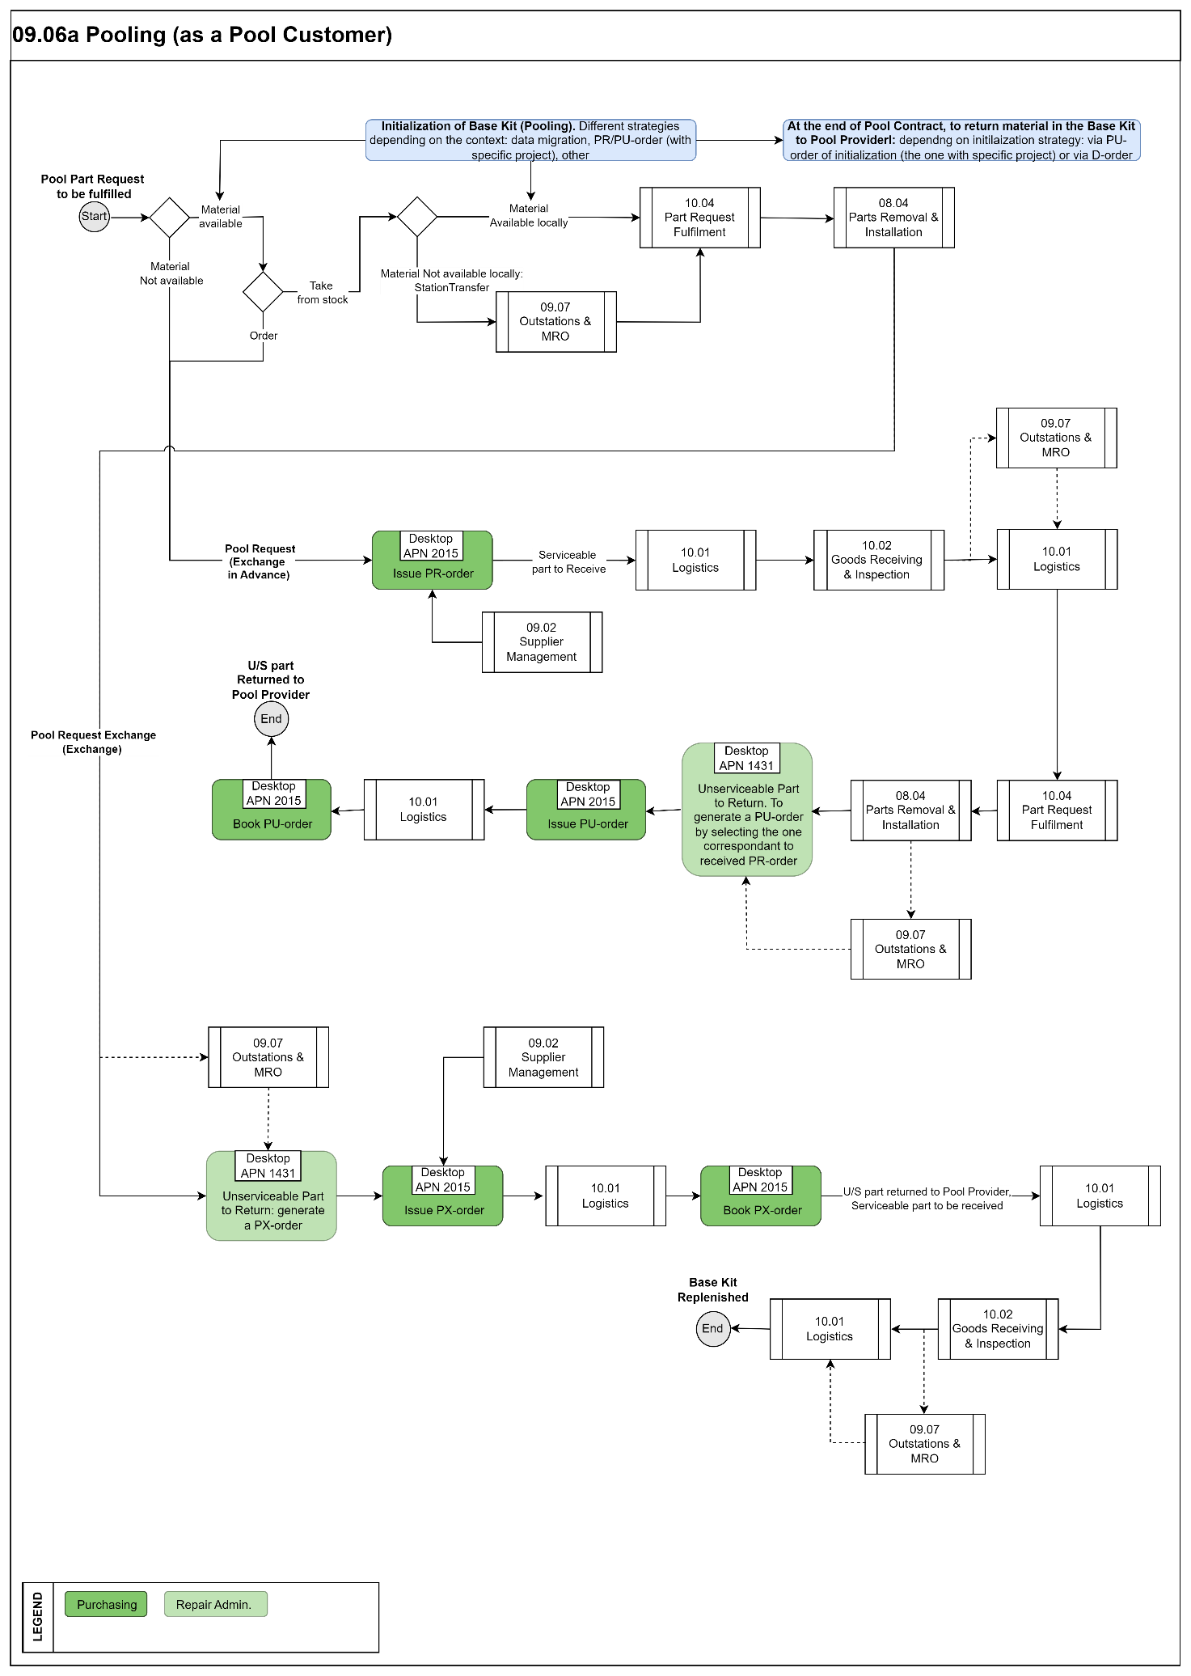
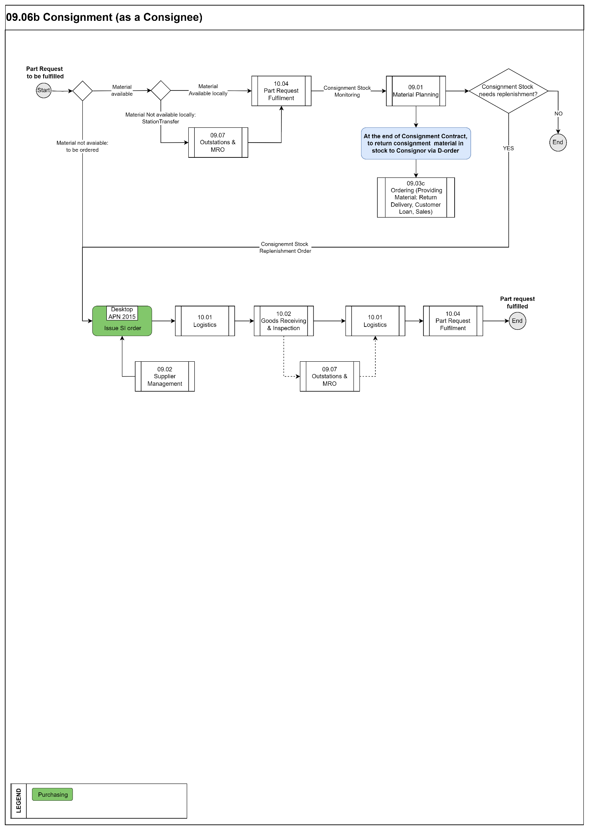

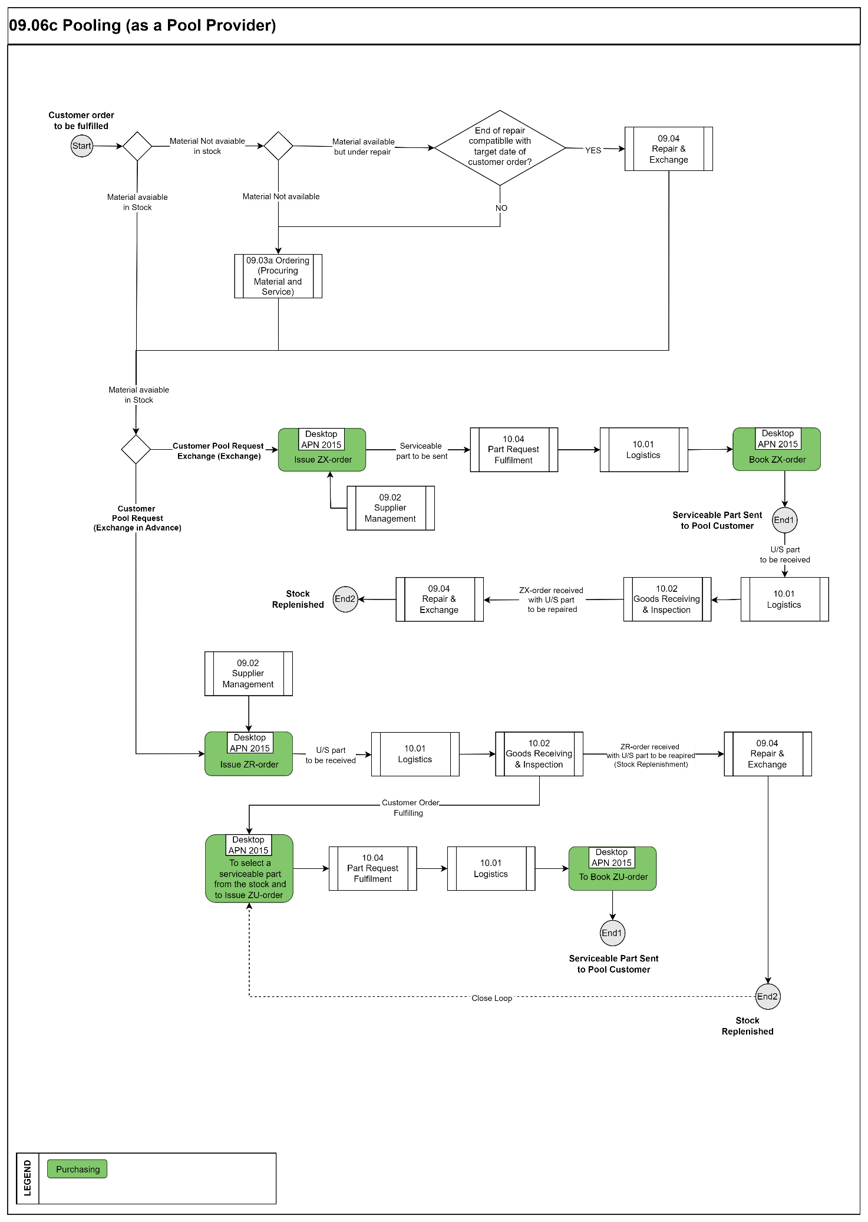

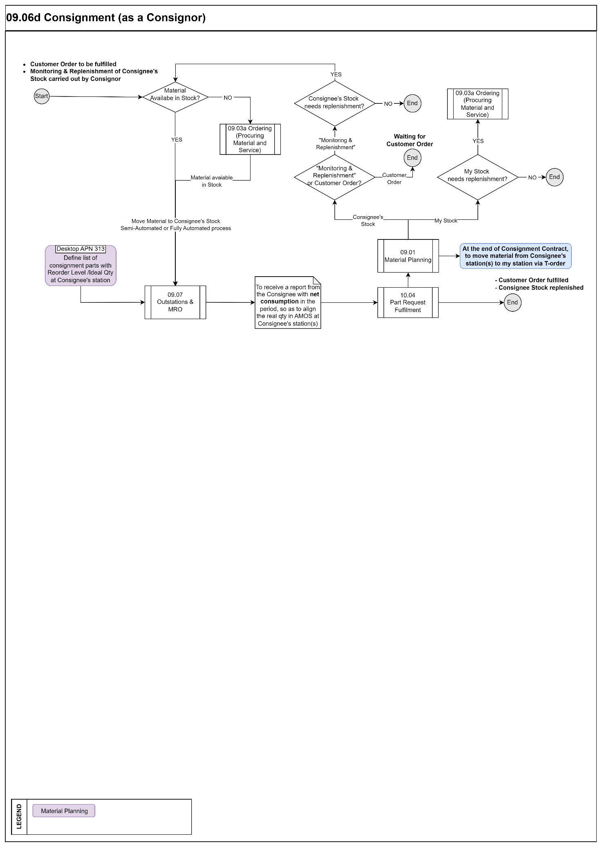

Process Design Questions
# | Question | Answer
1 | Will you need “pooling”?
2 | Are you a pool provider or a participant?
3 | How many and what kind of pool contracts you need to manage?
4 | How are the pool parts being invoiced to you?  (In case you are operating a simple contract (one fee for all aircraft), a PBH contract is as well available, in case this suits better to manage your contracts).
5 | Do you have consignment stock within your company? Are you a Consignee or a Consignor?
6 | How do you track consumption and control the consumption of consignment parts?
7 | Who will be the responsible to perform the owner change?
8 | Who will be the responsible to create the financial project?
9 | Who will be the responsible to edit (if needed) rotables ownership in Rotables Admin APN 147? what will trigger this action? will you use Technical Assistance to perform the request?

Data Source Mapping

Data Sources | Description | Volume / Manual / Automatic / Static / Dynamic
-/- | -/- | -/-

Other Software Used

Other Software | Used by: | Description
-/- | -/- | -/-

AMOS Configuration

Process specific configuration programmes
AMOS APN | Notes
-/- | -/-

Basic Data
Basic Data Table | Notes
Condition | Indicates the condition of a rotable relative to its traceability as it moves through its life cycle process.
Order Priority | Priorities used on every order. Codes like AOG, CRITICAL etc. is entered here.
Pool Order Type | Per pool contract an external pool order number, called "Pool External Order Type" format can be setup, as agreed with the pool provider. This number format is then generated automatically after order generation and first time saving the order in Order Management as an identifier for the pool provider when receiving the order.
Pool Reason | Reasons when ordering and sending parts to the pool provider, e.g. AOG Critical, Store, Replenish, etc. as they differ from the general order reasons.

Parameters
Parameter Code | Parameter Name | Notes
1550 | CREATE SP ORDERS AUTOMATICALLY WHEN SI ORDERS RECEIVED | Set to No
1790 | Consignment - Auto-Purchase logic | Activate Auto-Purchase Logic
1789 | Include SI-order and consignment stock | Set to Y
1793 | Consignment Order - Allow receiving on standard location
1164 | POOL CUSTOMER GROUP

Workflows
Workflow Number | Workflow Name | Workflow Setup Notes
231 | Verify Part Use Restriction
487 | Consignment Stock Decrease
486 | Consignment Stock Increase
2 | Booking an order (ID:2)
39 | Closed WO due to Repair Order (ID:39)
53 | Partno change on order (ID:53)
58 | SPEC2000 Order Notification (ID:58)
92 | Order Export (ID:92)
104 | LHT Material Request status changed (ID:104)
191 | Order Modification (ID:181)
214 | Order Confirmation received (ID:214)
237 | ATA106 Form Printed (ID:237)
242 | Book Order Detail (ID:242)
302 | Issue Order (ID:302)
352 | Issue Order Detail Before (Server)
91 | Approval Control-ID91
197 | Unknown Part Number Entered-ID197
181 | Modify an Order / Before
455 | Check Export Control for Orders / Before
459 | Check Export Control for order details
474 | Modify an Order Detail / After
497 | Execute an Order action / Before
498 | Save an Order / Before
499 | Issue an Order Detail / After
500 | Book an Order Detail / After
518 | Save an Order / After
519 | Book an Order / After
600 | Modify an Order / Before
638 | Book Order Detail / Before
612 | Issue an Order Detail / Before (Desktop)

Scheduled Tasks
Scheduled Task Reference | Frequency | Notes
SRTComponet-scheduler five interfaces existing to connect to the SRT pool | As requested. | Applicable only to SRT Technics

API’s & Interfaces
Reference | Direction | Trigger | Frequency
TRANSFER ORDER | Export | Order created / Issued / Booked / received /cancelled /modified (Export order information from AMOS) | As required
HAECO Interfaces. Several interfaces created for HAECO (licensed only to that customer) to handle Consignment contracts | Export/Import | Consignment Contract handling | As required/real time

UAT Guidance
1 | To create a Pool Contract as customer in APN 780 with a specific effectivity (PN and Aircraft) and Home Base. Effectivity of Part Number defined per “Part Special”
2 | In APN 2015 create a PR-order for the Pool Contract created to point above and to check the AMOS behavior if you try to enter a PN or an aircraft not compliant to effectivity
3 | In APN 2015 create a PX-order for the Pool Contract created to point above and to check the AMOS behavior if you try to enter a PN or an aircraft not compliant to effectivity
4 | In APN 204, select a part request in status “not available”, and create a PR-order for it without linking the part request to the order. Then observes the AMOS behaviour in PCF from the issuing of the order until the receiving of the part
5 | In APN 204, select a part request in status “not available”, and create a PR-order for it linking the part request to the order. Then observes the AMOS behaviour in PCF from the issuing of the order until the receiving of the part
6 | If PR/PX-order need approval, to create Approval Control rules and define and check AMOS behaviour for these order types
7 | To define a Consignment Contract in APN 780 and define Supply Scope and Price Book for some part numbers in the scope
8 | To create an SI-order from APN 899 for parts in status “Reorder Required”
8 | To create an SI-order from APN 204 for parts request in status “Unavailable” linking the order to the part request. Then, receives the parts and see the behaviour in APN 204
10 | To create an SI-order from APN 204 for parts request in status “Unavailable” without inking the order to the part request. Then, receives the parts and see the behaviour in APN 204. What is the difference compared to point 8 above?
11 | To create, issue and approve a SI-order in APN 2015. With/without Price Book.
12 | Try to approve/not approve vendors (APN 53) and see the AMOS behaviour in APN 2015
13 | To create a Pool Contract as provider in APN 780 with a specific effectivity (PN and Aircraft) and Home Base. Effectivity of Part Number defined per “Part Special”
14 | In APN 2015 create a ZR-order for the Pool Contract created to point above and to check the AMOS behavior if you try to enter a PN or an aircraft not compliant to effectivity
15 | In APN 2015 create a ZX-order for the Pool Contract created to point above and to check the AMOS behavior if you try to enter a PN or an aircraft not compliant to effectivity

Annex – Additional Info
-/-

